Restoration of azure VM

- Activate your roles for restore the VM. (VM contributor, storage contributor, disk contributor and VM restore operator).
- Go to the Virtual machine Stop the Virtual machine and then backup console and click on Restore VM option.

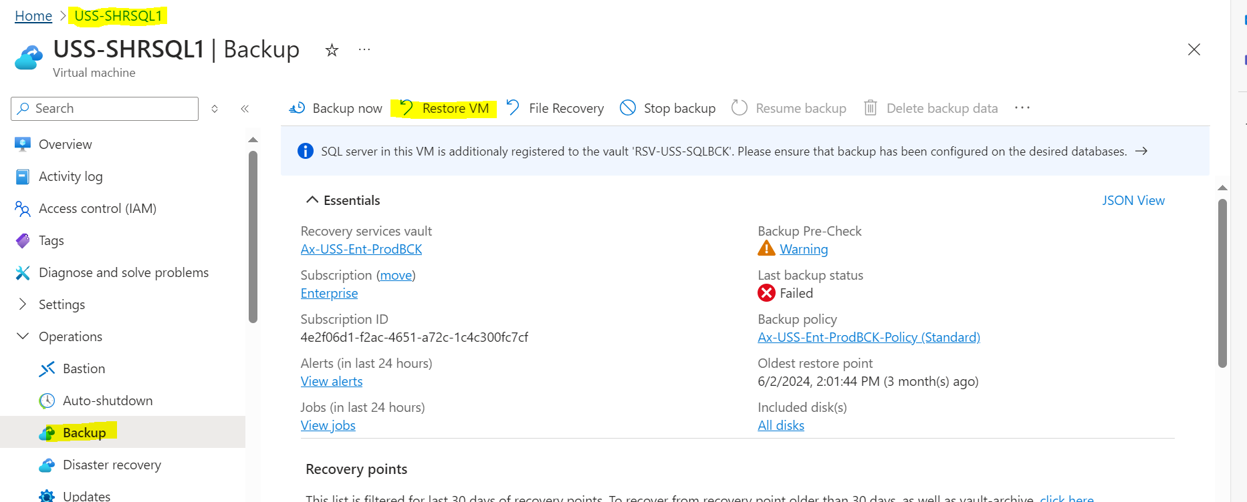

- Select the restoration date and time and then click OK.
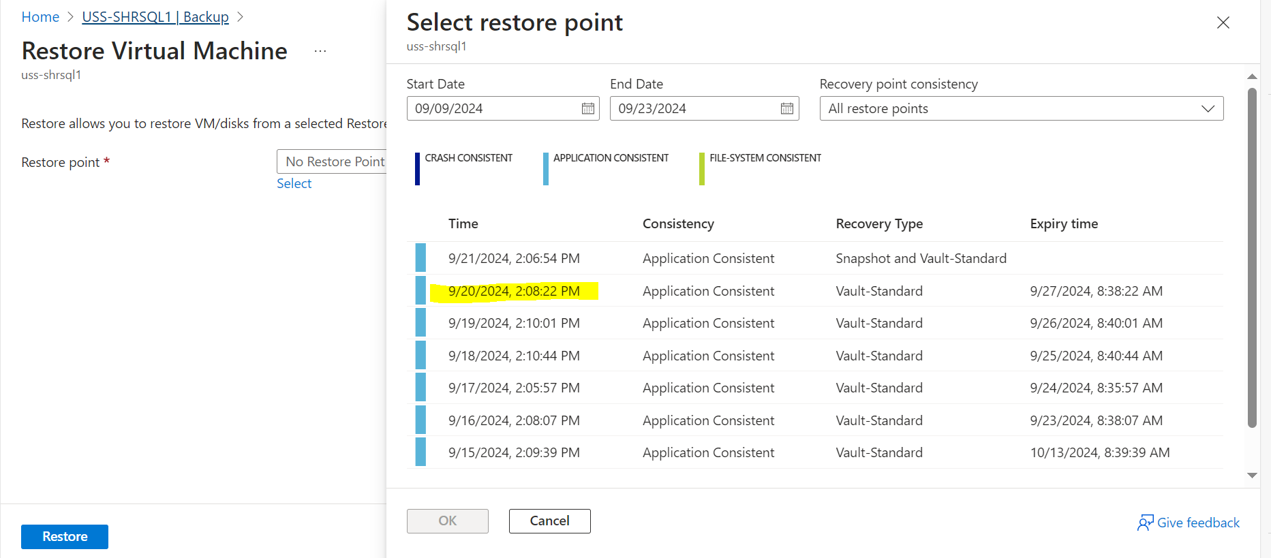

- Select the replace existing and then staging location.
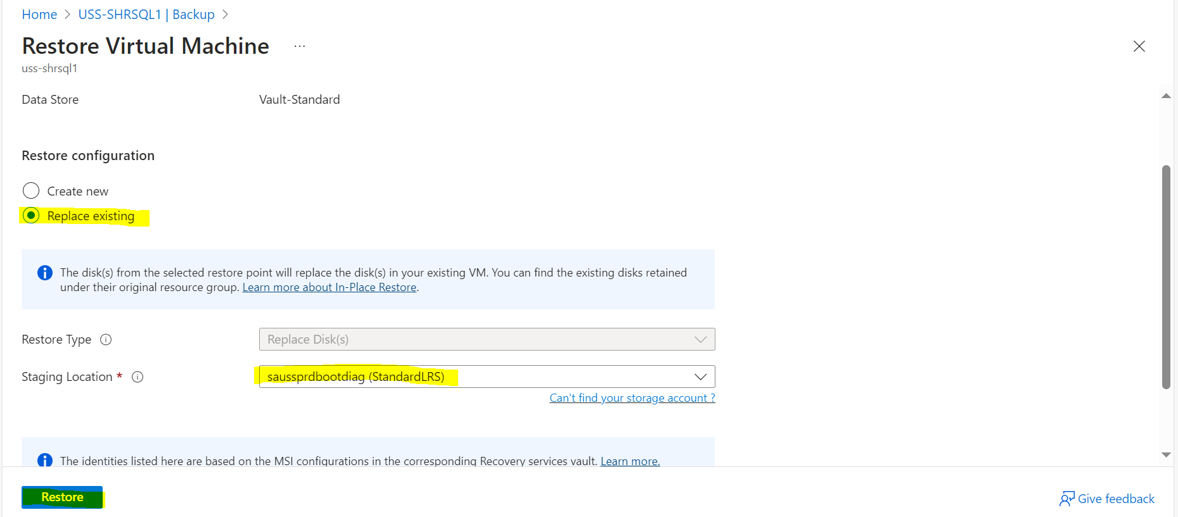

- Click on restore button and then check the status from View jobs Option.

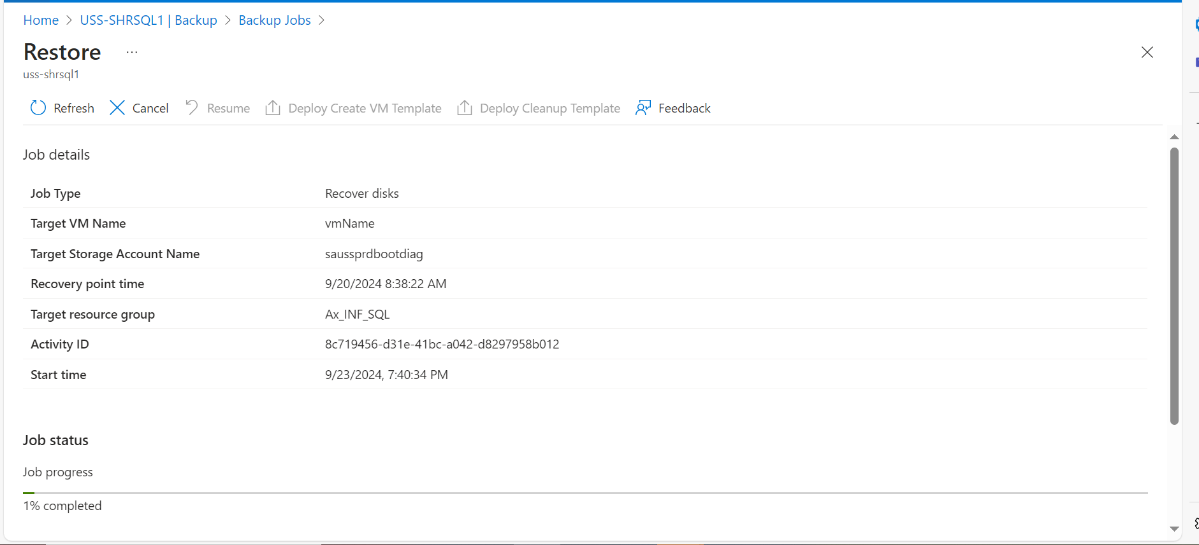

Once it will be 100 % completed start the VM.

